Gitter, Jeff
Jeff.gitter@infoworks-tn.com
Abstract
Track inventory, sales, in-transit QOH and receipts for consignment warehouses
Consignment warehouse user guide
Version 1.3 10/5/2018

Contents
Introduction 3
Team Members 3
Audience and Permissions 3
List of Warehouses 4
Accounts Receivable (AR) vs Non-Accounts (Non-AR) Receivable Warehouses 4
Application Links 4
Import Consignment Warehouse Reports 5
General Instructions 5
Inventory Position Data 7
Is Missing Flag 7
Inventory Variance Flag 7
Sales and Returns Data 8
Gratis Data 8
Receipt Data 9
Warehouse-Specific Considerations 9
GBS 9
NSB 9
PGC 9
Wiley UK 10
Wiley Amazon Advantage 10
MHM 10
Footprint 10
APD 10
Consignment Data Adapter Format 11
Inventory Variance View 12
Delete Imported Files 12
Inventory Control Adjustments 14
Manual Adjustment 14
Autofix 15
Fix All 15
Inventory Position Release and Reporting 16
Daily Report Job: Inventory Position 16
Importing and Reconciling In-Transit Data 16
Inbound Shipment Tab 17
Inbound Shipment Reconciliation 17
Daily Report Job: In-transit Ledger 18
Automatic Receipt Reconciliation 18
Receipt Release and Reporting 19
Sales/Returns Data Release and Reporting 19
Client Statements Integration 20
Customer Mapping 20
Publishing Consignment Warehouse Data 21
Invalid EANs 21
Inventory Position Invalid Release Rules 23
Receipt Invalid Release Rules 23
Sales/Returns Invalid Release Rules 23
Discarded EANs 23

Introduction
Consignment Warehouse collects inventory position, receipt, and sales data from international consignment warehouses, and reports that data to Ingram’s clients (publishers)

Team Members
Name | Role
Dan Weese | Program Lead
John McKenzie | Project Manager
Jeremy Randolph | Development Lead
Barbara Pitcher | IPS-Jackson Finance SME
Steve Danz | IPS-Jackson Inventory SME
Arnab Kar | Architect and Developer
Brian Clausel | VendorLink Developer
Jeff Gitter | QA Lead

Audience and Permissions
Consignment Warehouse is an Ingram internal application. Any user on the Ingram domain may view data, and users may import data if they are members of one or more AD groups
AD Group | Privileges granted
Inventory  IPS_CWH_InventoryControl | - Import Inventory Position files  - Import Receipt files  - Reconcile Receipt files to in-transit ledger items  - Create inventory control adjustments  - Delete Inventory Position files  - Delete Receipt files  - Release Invalid Items  - Approve Inventory Position data  - Approve Receipt data  - Publish data
Finance  IPS_CWH_Sales | - Import Sales files  - Import Returns files  - Delete Sales files  - Delete Returns files  - Release Invalid Items  - Approve Sales and Returns  - Publish data
VendorLink  VendorLinkAdmin | - Manage VendorLink configurations  - View existing VendorLink processes  - Fix and release cleansed data
Ingram domain users | - View data
Public domain | - No access

List of Warehouses

Accounts Receivable (AR) vs Non-Accounts (Non-AR) Receivable Warehouses
Sales and returns from AR warehouses affect Ingram’s general ledger, while Non-AR warehouses do not. Therefore, Ingram is obliged to track in-transit quantity on hand (QOH) for AR warehouses only.

AR Warehouses
Warehouse Name | Warehouse Code
Grantham Books | CG
NSB | CN
PGC | CP

NonAR Warehouses
Warehouse Name | Warehouse Code
Wiley UK | CW
Wiley Amazon Advantage | CA
MHM | CM
Footprint | CF
APD | CS

How to Add a Consignment Warehouse
For a full list of technical steps required to add a consignment warehouse, please refer to the following Confluence page: https://wiki.ingramcontent.com/display/IPSPI/How+to+Onboard+a+new+Consignment+Warehouse

Application Links
Environment Name | Link
QA | https://consignmentwarehouse-qa.ingramcontent.com/
UAT | https://consignmentwarehouse-uat.ingramcontent.com/
Production | https://consignmentwarehouse.ingramcontent.com/

Import Consignment Warehouse Reports
Different warehouses provide their reports in various formats. The instructions below provide general instructions, followed by warehouse-specific variances.

General Instructions
- Navigate to the warehouse for the data to be imported by clicking the “Import Log” link.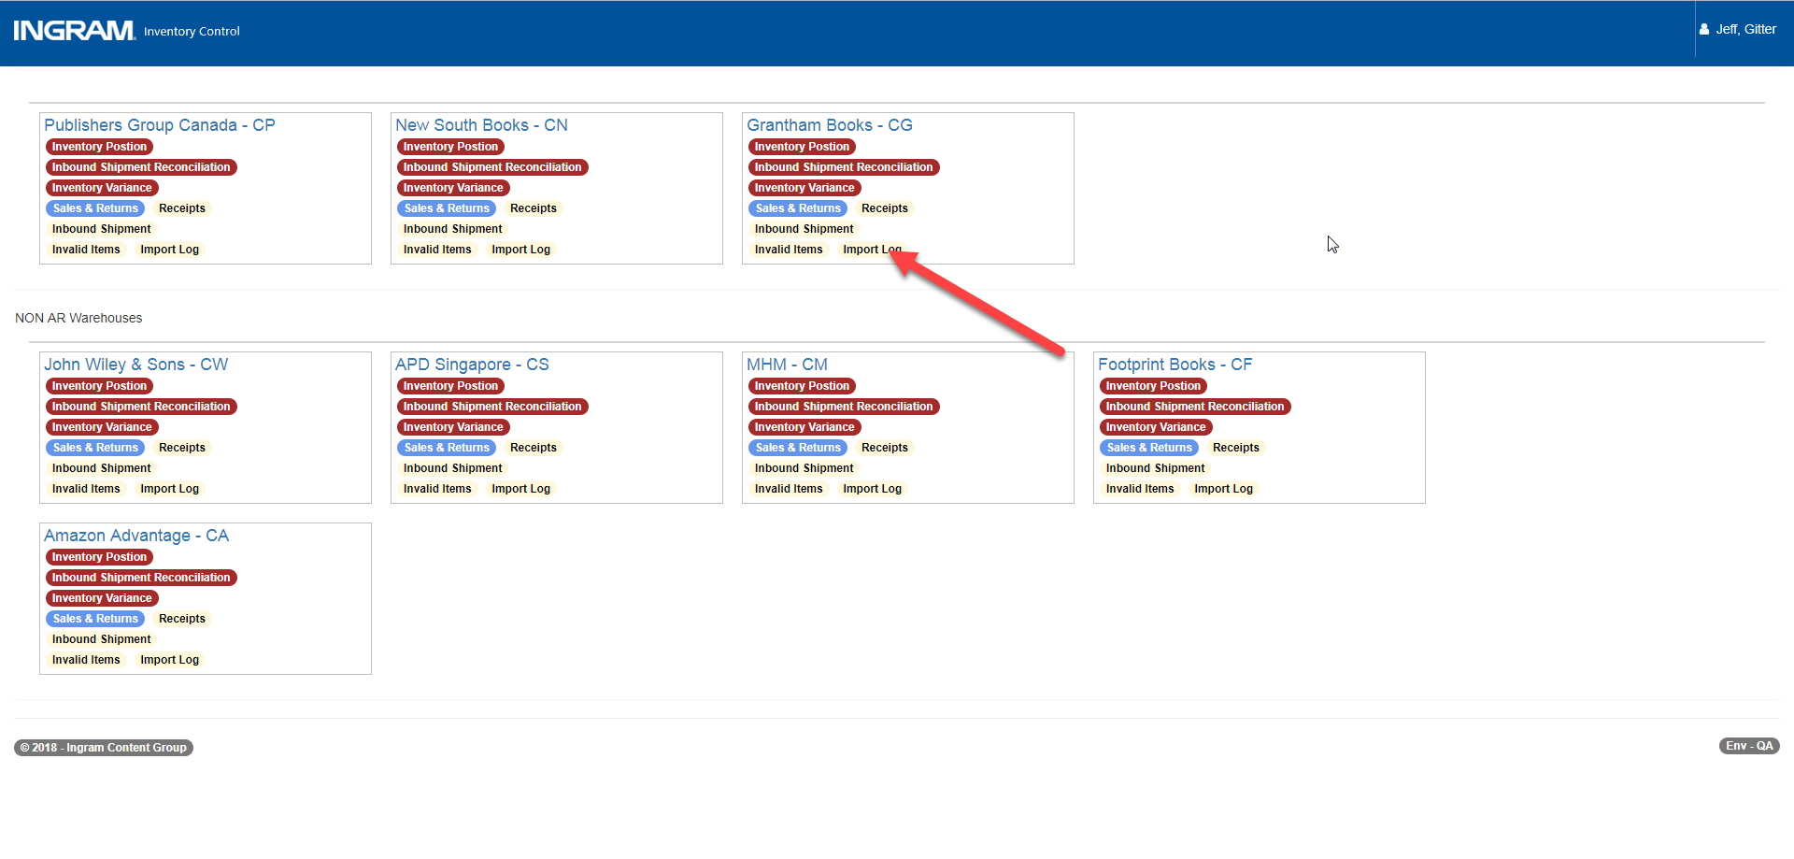
- Select the desired month using the date-picker, then click “Upload File”.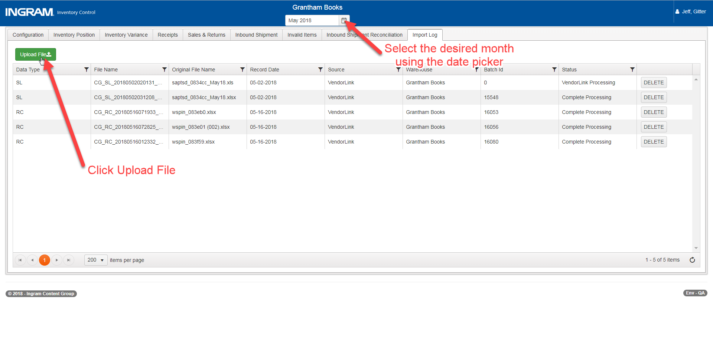
- Select the appropriate data type and the file date. Users may upload a file to any date, regardless of which month is selected above the grid.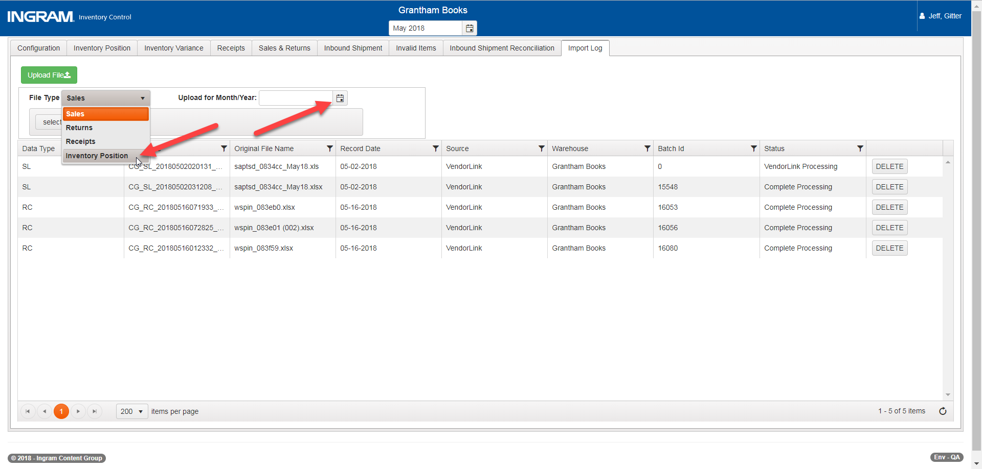
- Click the “Select File” button and choose your file from windows explorer. Click “Upload” to upload the file to VendorLink.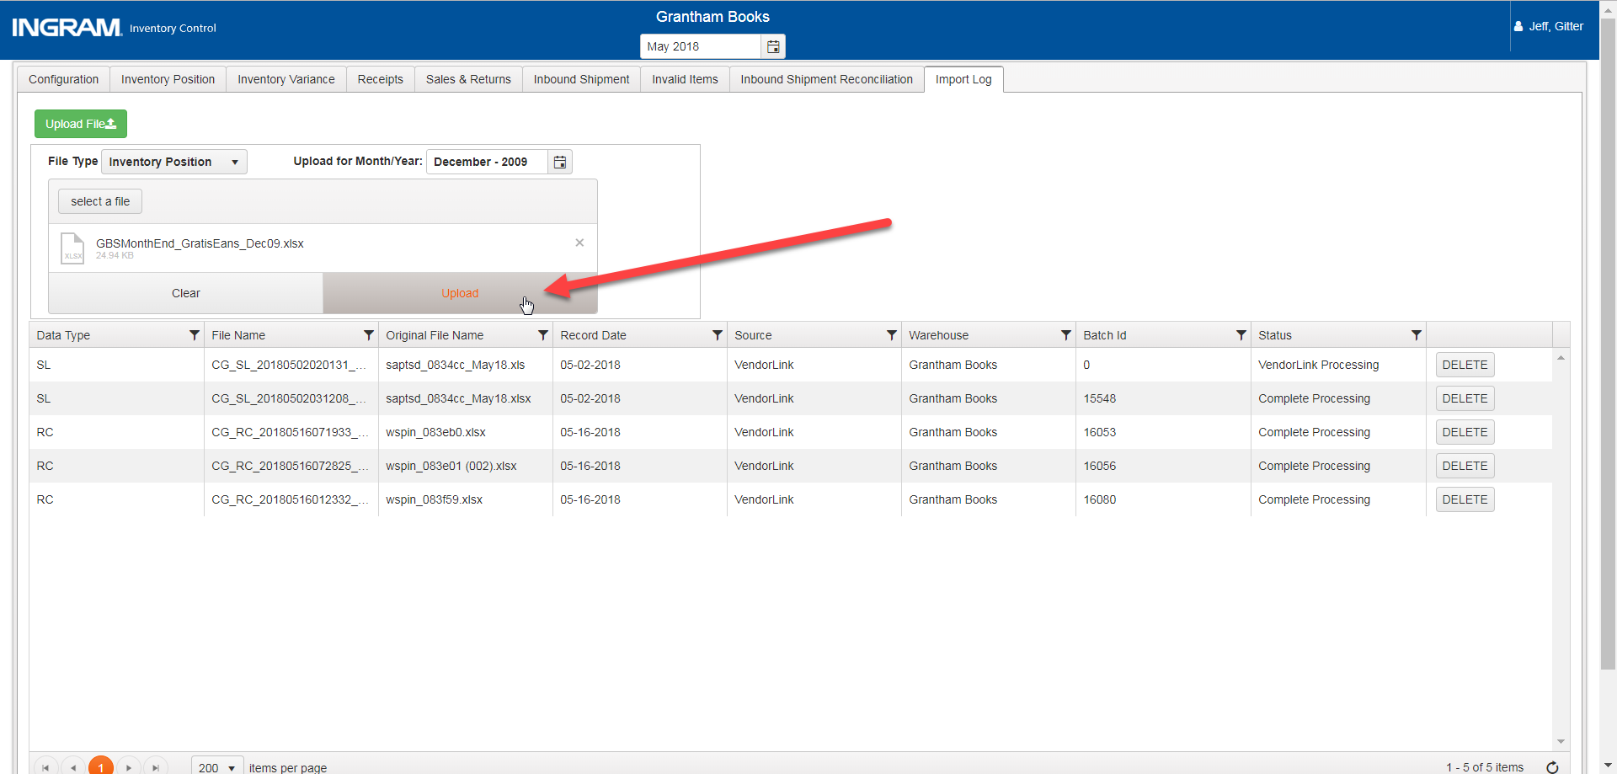
- VendorLink will transform the file to consignment warehouse’s data format, based on the selected data type. The Status will show “VendorLink Processing” until Consignment Warehouse receives a notification from VendorLink that the data has been exported. Note very file imported through VendorLink is supplied a batch ID. This identifier may be used across all views within the application to identify data imported from the same file. For more information on Vendorlink’s mapping and processing, please contact IT Support.
- Once the message has been sent, Consignment Warehouse updates the Status to “Complete”, and then imports the data from VendorLink and displays it in the appropriate tab.

Inventory Position Data
Partner warehouses are required to send a summary of monthly inventory activity in a single file. Inventory Control may import this file using the import process outlined above. Only one inventory file may be imported for each warehouse and month.

Is Missing Flag
If an EAN was reported in the inventory position file last month, and is not reported this month, then the row will be included in this month with the “Is Missing” flag applied, and a closing balance of zero. If the EAN was correctly removed from the report, no action is required. However, if the EAN should have been included, Inventory Control may delete the inventory position file and import a corrected file. (See section “Delete Imported Files” for more information.)
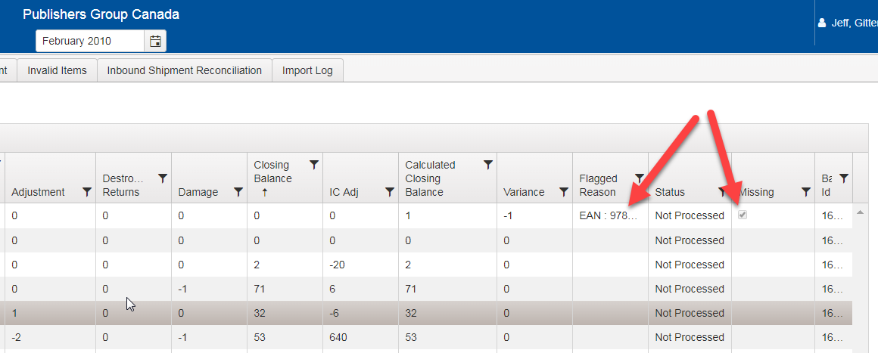

Inventory Variance Flag
When an EAN’s closing balance from the previous month (shown as “Balance carried forward” on the current month’s Inventory Position tab), plus the adjustments for this month does not equal the reported closing balance, then that EAN will be flagged for review by inventory control. The controls for creating Inventory Control Adjustments appear when the EAN is flagged, and validation will prevent the inventory position data from being released until all variances have been corrected
Note this flag is not applied when the inventory summary position for sales, returns or receipts does not match the quantities reported from other reports! See Section “Inventory Variance View” for more details on the Inventory Variance view
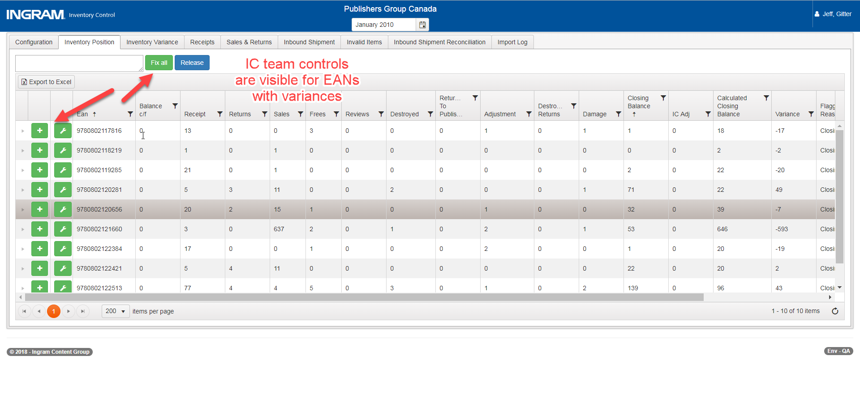

Sales and Returns Data
Sales and Returns data is imported by selecting the file type “Sales” or “Returns”. Users must be members of the Finance AD group to select the “Sales” or “Returns” option. The date selected will determine which month the file metadata is displayed in the Import Log, but the sales/returns data itself will be imported based on the transaction sale date from the data itself. For example, if a file is uploaded for May 2018, but the sales occurred in April 2018, then the Import Log will show the file in May 2018 but the sales/returns data itself will be visible in April 2018. If a warehouse provides sales and returns data together in one report, the sales and returns will be imported together. If sales and returns are reported in separate excel sheets, then the sales and returns must be imported separately
Import Single “Sales” file | Import separate “Sales” file for invoices and “Returns” file for credits
GBS | Wiley UK
NSB | MHM
PGC | APD
Footprint | (Wiley Amazon does not report returns)

Gratis Data
Gratis data is imported by selecting the file type “Gratis”. Gratis data will be reported like regular sales data, but without a net value associated with the transaction. Both AR and non-AR warehouses may upload gratis files, through gratis data may be supplied via the sales file. The table below outlines how each warehouse imports Gratis data
Warehouse | Imports Gratis file? | File used to import gratis
GBS | No | Gratis imported with Sales file
NSB | Yes | Sales file imported with gratis file type
PGC | No | Gratis imported with Sales file
Wiley UK | Yes | Wiley trans file
Wiley Amazon | No | No gratis transaction provided
MHM | Yes | Sales file imported with gratis file type
Footprint | Yes | Sales file imported with gratis file type
APD | Yes | COMPS file

Receipt Data
Receipt data is imported by selecting the file type “Receipts”. Both AR and non-AR warehouses upload receipts, although tracking in-transit data is not contractually required for non-AR warehouse. The date selected will determine which month the file metadata is displayed in the Import Log, but the receipts data will be imported based on the transaction date from the receipt file. For example, if a file is uploaded for May 2018, but the receipt occurred in April 2018, then the Import Log will show the file in May 2018 but the receipt data itself will be visible in April 2018.
When imported, receipt data will automatically be matched to existing in-transit ledger items by PO number and EAN, then by invoice number and EAN. If the receipt has a quantity larger than the in-transit item it may not be matched. See section “Importing and Reconciling In-Transit Data”.

Warehouse-Specific Considerations

GBS
- GBS files may be downloaded from an online portal in an .xls format. Vendorlink requires a .xlsx format so the downloaded file must be converted manually
- Titles that include quote characters are offset by one column per quote character on the inventory position and sales files. These files need to be manually corrected, or VendorLink will remove the row during the cleansing process
- Gratis transactions are imported with the sales data

NSB
- NSB’s Inventory Position file is also used to report sales and gratis

PGC
- Files are not sent in Excel 2007 format, and must be copied into Excel before being uploaded
- Receipts are sent as a list of invoice numbers in an email. To create the receipts file, the invoice numbers must be found on the Inbound Shipment tab then added to a receipt file before being imported
- Inventory position data is sent in a series of transaction-level text files, and VendorLink requires an excel file with summary data by EAN. Inventory Control must aggregate the transaction-level data into a single summary report. Please reach out to Steve Danz (IPS-Jackson Inventory Control Manager) for questions about this process
- Gratis transactions are imported with the sales data

Wiley UK
- Wiley UK’s adjustment file (inventory position) includes an adjustment column for “Consignment Stock”. This value is applied to Wiley UK’s inventory as an adjustment, and represents stock being transferred to or from Wiley’s Amazon Advantage warehouse
- Wiley UK’s invoice (sales) file includes a column “Consignment C2”, and if that column includes a “C2” value, then the sale was made from Amazon Advantage and this sale will not be reported under Wiley UK.
- To import receipts, upload the Wiley UK adjustment file with the file type “Receipts” selected

Wiley Amazon Advantage
- Wiley Amazon Advantage uses the same reports as Wiley UK to report inventory position and sales transactions, and the files must be imported separately
- All Wiley UK inventory EANs are imported as Amazon Advantage EANs as well, but will maintain a balance of zero unless items are added as a positive value in the “Consignment Stock” column
- Amazon Advantage’s closing balance is calculated from last month’s closing balance + consignment stock adjustments. No variances will exist for Amazon Advantage because this calculation directly sets the closing balance
- Amazon Advantage sales transactions do not affect the reported inventory position
- Amazon Advantage does not report receipt or gratis data

MHM
- MHM provides a single excel document that includes inventory position, sales and returns on separate sheets. The same file must be uploaded three times as an inventory position, sales, and returns file type because VendorLink extracts, transfers and loads one sheet at a time
- The separate sheets may not be uploaded with one VendorLink workbook because that would prevent users from deleting data after any data type has been approved (e.g. if all MHM data is imported together and inventory position data has been approved, the sales data may not be deleted in Consignment Warehouse.)
- To import receipts, upload the MHM inventory file with the file type “Receipts” selected
- To import gratis, upload the MHM inventory file with the file type “Gratis” selected

Footprint
- Footprint handles stock for two publishers: Princeton and California. Princeton reports data monthly and California reports quarterly in two separate files. Inventory Control users must combine the separate files when importing to avoid removing California’s stock as “missing” titles. Please reach out to Steve Danz (IPS-Jackson Inventory Control Manager) for questions about this process
- To import receipts, upload the Footprint inventory file with the file type “Receipts” selected
- To import gratis, upload the MHM inventory file with the file type “Gratis” selected

APD
- To import receipts, upload the APD inventory file with the file type “Receipts” selected

Consignment Data Adapter Format
As part of the development effort, warehouse partners were requested to provide their data in a standard format to simplify VendorLink’s data transformation. The adapter request includes the implementation of dropping files in an FTP location that VendorLink can pick up automatically with a configuration change. As of August 2018, GBS and NSB have begun the process of implementing this format.
For details regarding this standard format, please see the following wiki page: https://wiki.ingramcontent.com/display/IPSPI/Consignment+Warehouse+Partner+Data+Adaptor

Inventory Variance View
By default, Consignment Warehouse does not validate that the receipt, sales, and returns data matches to the summary data provided on the inventory position file. However, the Inventory Variance view provides a tool by which inventory control professionals may easily identify variances between the inventory position summary data and the receipt, sales and returns data.
Note that sales and receipt data shown in this view depend on the transaction date supplied in the sales and receipt files, respectively. If the sales data is reported in the month after the actual sales transactions occurred, then those sales transactions will not appear in the same month as the inventory summary report.
The Inventory Variance view does not provide any tools for correcting variances. If a variance is found, users must delete the file that caused the discrepancy, and then import a corrected file. The view will automatically update once refreshed. See the screenshot below for additional details: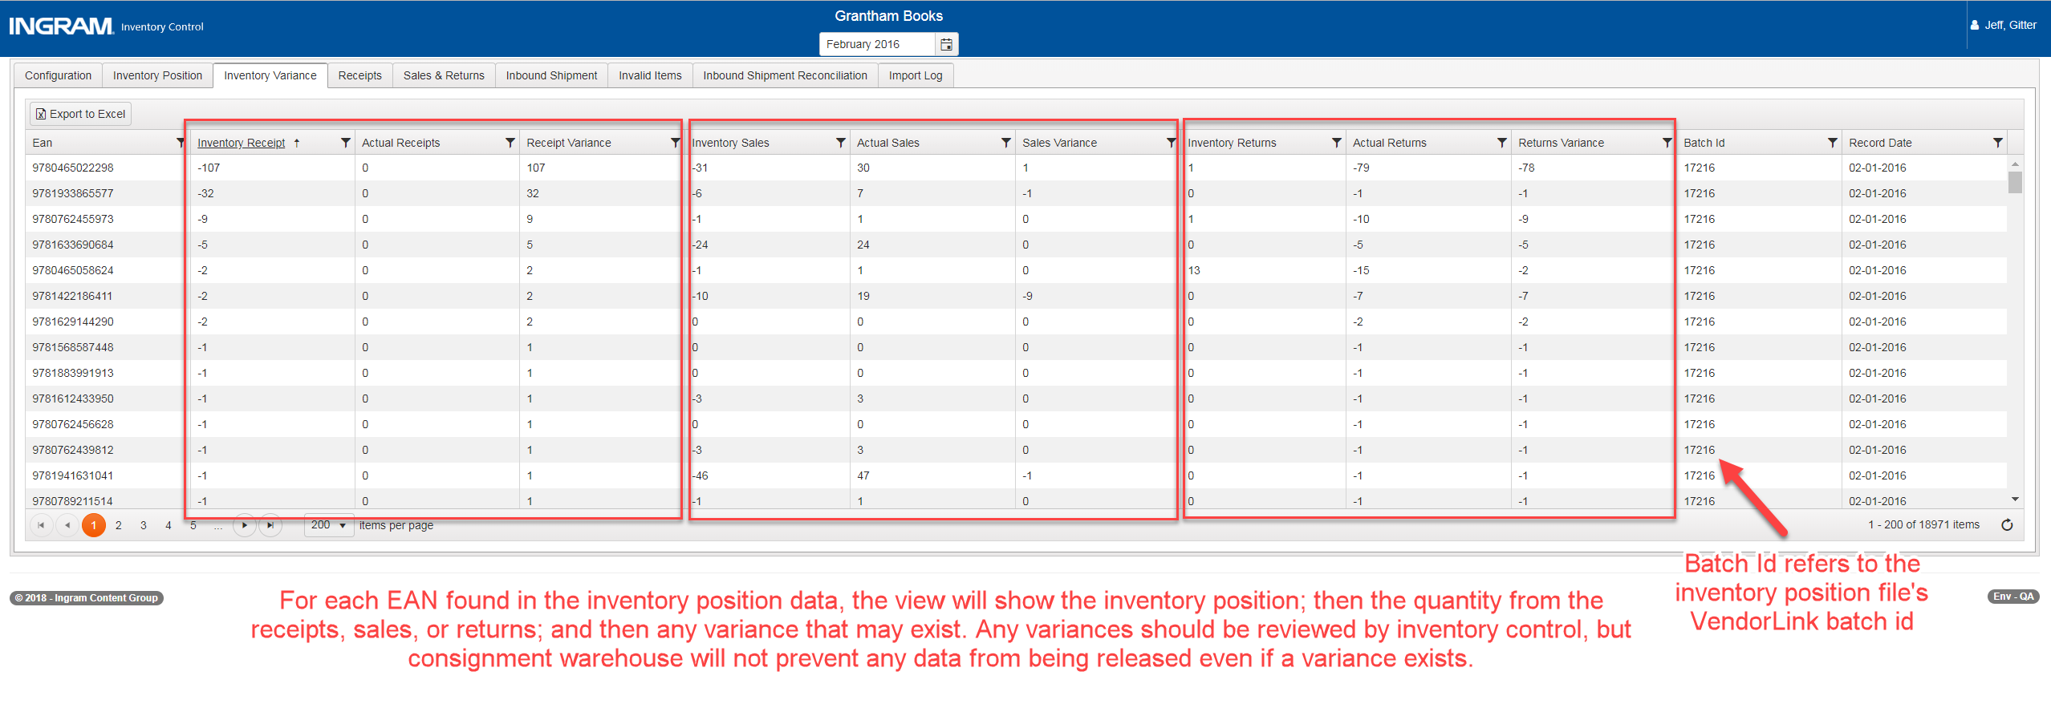

Delete Imported Files
Inventory control and finance team users may delete data that has not been released by deleting the file from the import log. When the file is deleted, all records that were imported as part of that file will also be deleted by their batch id. This includes any items that were added to the invalid EAN queue. If any items from that batch have been released, then the file may no longer be deleted since the data was reported to the publishers.
Note that for sales and receipt data, the imported data will be displayed based on the row’s record date, but the file will be displayed under the month the user selected when uploading the file. For example, if a user uploads a receipt file with record dates of May 2018, but selects June 2018 while uploading the file, the file will appear in June 2018 on the Import tab but the data will appear under May 2018.
Files may not be deleted if they have the status “VendorLink Processing”. This validation prevents files from being deleted before data is pulled from VendorLink; however, if an error occurs in VendorLink then the file may not be deleted.

To delete a file, navigate to the import tab for the warehouse and month the file was uploaded to by clicking the “Import Log” link on the consignment warehouse dashboard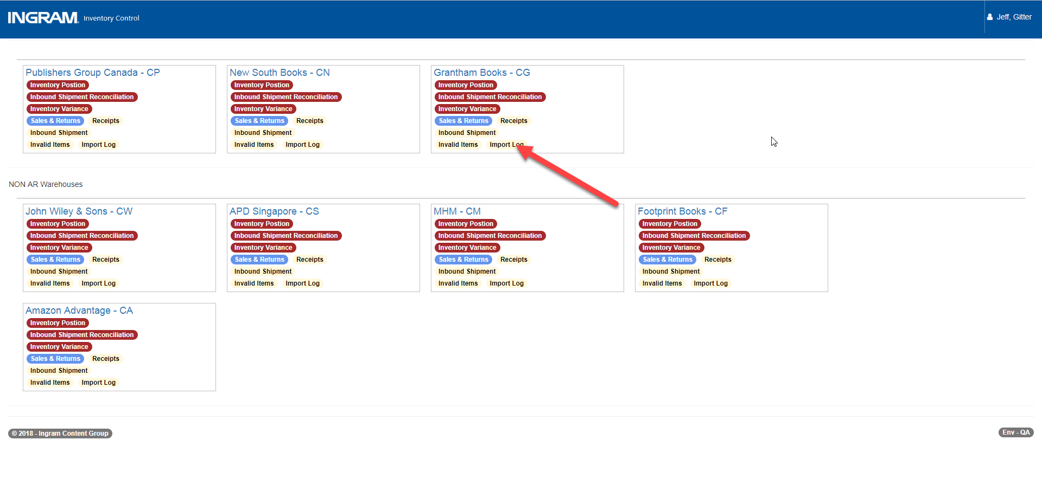Navigate to the appropriate month, locate the file to be deleted, and click the “Delete” button
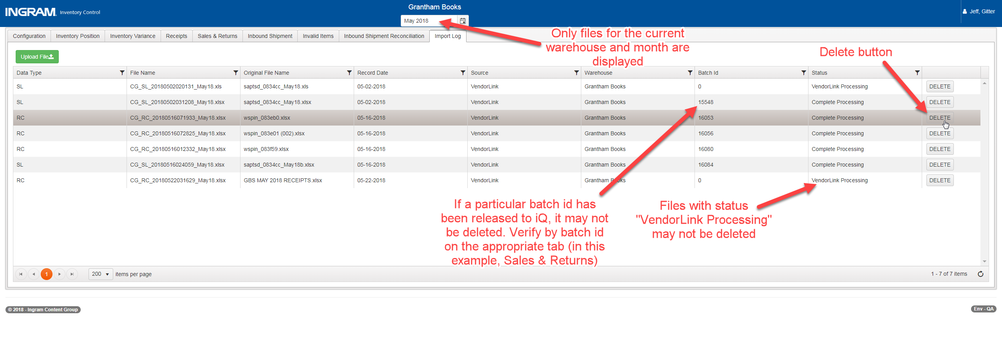

Inventory Control Adjustments
Variances between last month’s closing balance plus the sum of all adjustments from this month and this month’s closing balance are flagged when the inventory position data is imported. If any variances are found, consignment warehouse will provide three tools for Inventory Control to correct the variances: Manual Adjustment, Autofix, and Fix All.
Adjustments created by inventory control will be reported to iQ as generic adjustments, and the reasons provided for manual fix and fix all will remain visible within the Consignment Warehouse application.

Manual Adjustment
Inventory control professionals may create an adjustment with any adjustment type, quantity and note they see fit. This should be the most common kind of adjustment since it provides the clearest audit record.
To create a manual adjustment, click the green “+” button and complete the form
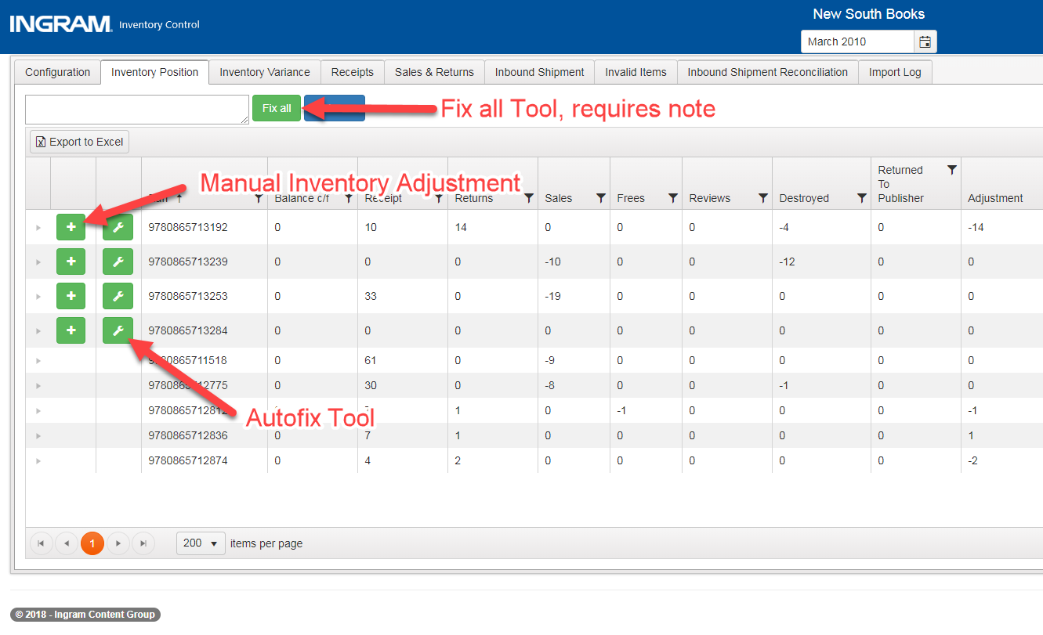
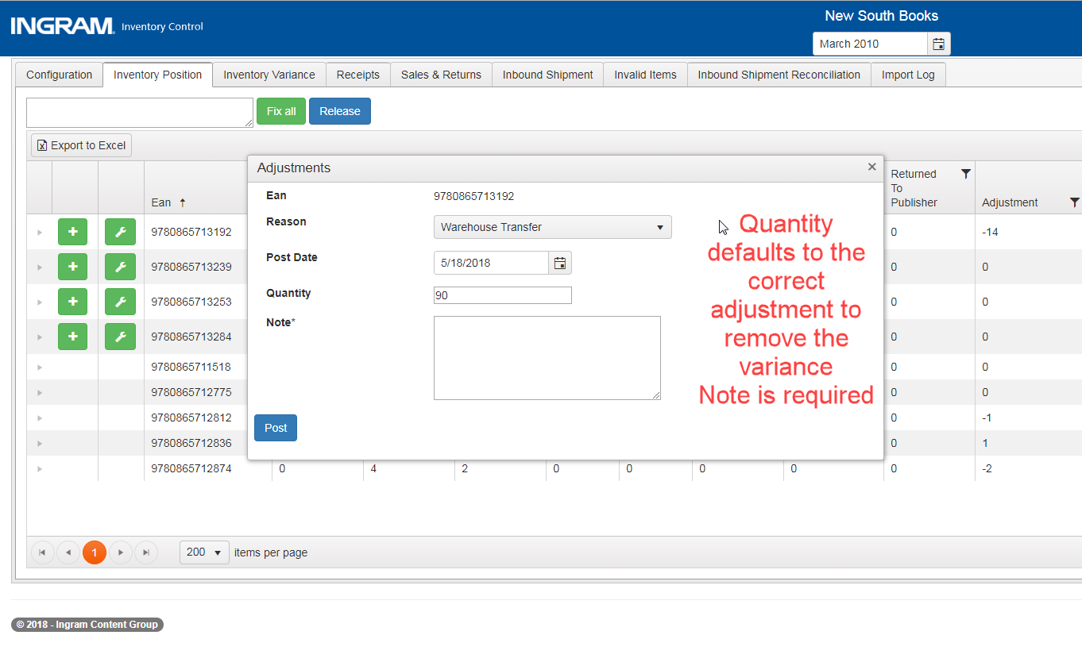

Autofix
In certain instances, inventory control may decide the reason for an inventory position variance is unknown, or the variance will be corrected in next month’s statement. In these cases, they may correct the variance automatically for a specific EAN by clicking the “autofix” button. No note is provided for “autofix”, so this should be used for correcting small variances only.

Fix All
If many inventory position variances occur for the same reason, inventory control may choose to correct all remaining variances using the “fix all” tool. A note is required, and the “fix all” functionality will ignore any filters applied to the grid.

Inventory Position Release and Reporting
Inventory Position data may be released for reporting to publishers by clicking the “Release” button. Inventory may be released at any time throughout the month, and only inventory control users may release inventory. Inventory positions may not be released if any variances still exist for the selected month, and the data will not be visible in Qlik or iQ until it has been published. See section Publishing Consignment Warehouse Data for more information.
AR warehouses release quantity on hand (QOH) and adjustment data to the F_Inventory_Snap and F_Inventory_Tran tables in the ODS database. Non-AR warehouses release to the NonAR_F_Inventory_Snap and NonAR_F_Inventory_Tran tables. For details on how the data is mapped to these tables, please see the following Confluence page: https://wiki.ingramcontent.com/display/IPSPI/Reporting+-+Inventory+Adjustment+Codes
The inventory approval also sends gratis summary data to the F_Sales table for AR warehouses and NonAR_F_Sales for NonAR warehouses. These will be shown as sales with $0 and will be flagged as frees. Therefore, gratis quantities for a given warehouse, month, and EAN will be shown as a single sales transaction for the entire month that has no effect on Client Statements.

Daily Report Job: Inventory Position
Every day the inventory position data is not released for a given warehouse, the Consignment Warehouse Daily Report job will send the latest known inventory position by batch id to the F_Inventory_Snap and NonAR_F_Inventory_Snap table at 7pm. This daily process was created to account for the ODS data model which assumes inventory position is reported daily. Therefore, the data in Qlik and iQ will appear to report daily inventory positions based on the provided monthly data. The Daily Report job does not run on the same day the warehouse’s inventory position data was released because the inventory release process updates the quantity on hand. The Daily Report job also sends in-transit data to ODS, please see section Daily Report Job: In-transit Ledger for details.
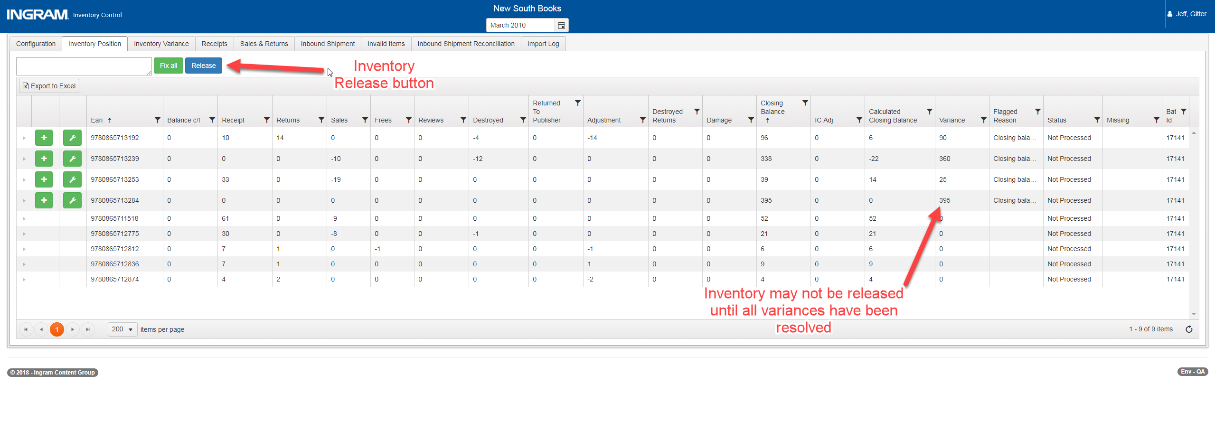

Importing and Reconciling In-Transit Data
Consignment Warehouse imports in-transit ledger items from OMS and iPage. OMS data represents stock transfers from anywhere in the world to a consignment warehouse, and iPage data represent bindery shipment notifications entered by the publishers. iPage bindery shipment notifications are imported when the iPage job runs at 8am, and OMS stock transfers are imported ad hoc. In-transit data is not required for reporting receipts, and will be displayed in iQ when the daily report job runs at 7pm
(see section “In-Transit Data Reporting” for more detail).
Both services will import data automatically without needing to import any files through VendorLink. To view data that has been imported, two tabs are available: the Inbound Shipment tab and the Inbound Shipment Reconciliation tab.

Inbound Shipment Tab
The inbound shipment tab shows all the in-transit ledger items that were received in the given month, regardless of whether a receipt has been matched to the in-transit item. This tab is meant to be used as a historical record of in-transit items, where the daily reconciliation activity will happen on the Inbound Shipment Reconciliation tab.
The nested grid displays receipts that have already been matched to the in-transit item. Users may not reconcile in-transit items to receipts from this view.
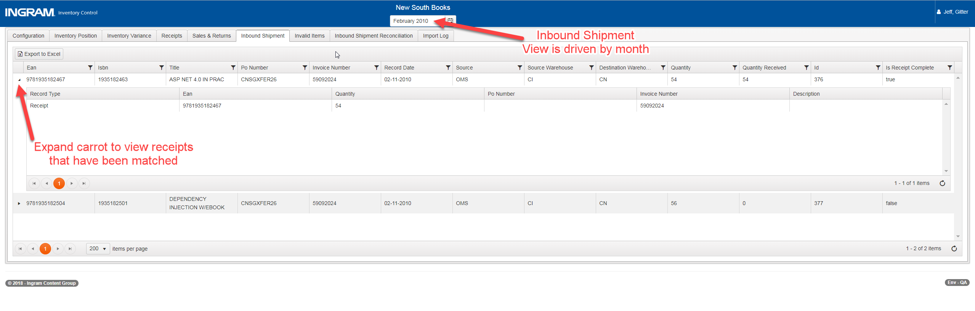

Inbound Shipment Reconciliation
The inbound shipment reconciliation tab shows all the in-transit ledger items for the current warehouse that have not been matched to a receipt, regardless of month. This page is designed to help the inventory control team easily match receipts to in-transit items by EAN. To match a receipt, expand the caret for the in-transit item and click the “Reconcile” button.
The nested grid displays receipts that are potential matches to the in-transit item but have not been matched yet. Once the receipt has been matched, it is removed from all nested grids where it would have otherwise appeared. To view existing matched receipts, please see the Inbound Shipment Tab.
Inventory control users may match many in-transit items to a single receipt, and many receipts to a single in-transit record. Once an in-transit record or receipt transaction have been matched, they may not be matched to another record and will disappear from the inbound shipment reconciliation page unless additional quantity exists. For example, if an in-transit ledger item of 10 units is matched with a receipt of 7 units, the 7 receipt units may not be matched and only 3 units from the in-transit item may be matched to another receipt. The receipt would disappear from the inbound shipment reconciliation view and the in-transit item would show 3 remaining units. If the remaining in-transit units are matched to a new receipt of 10 units, then 7 quantity of the receipt would remain available to be matched to another in-transit item.
Inventory control users may also write off an in-transit item if they know it will not be received. This will create a system adjustment transaction in Qlik and iQ to remove the in-transit quantity.
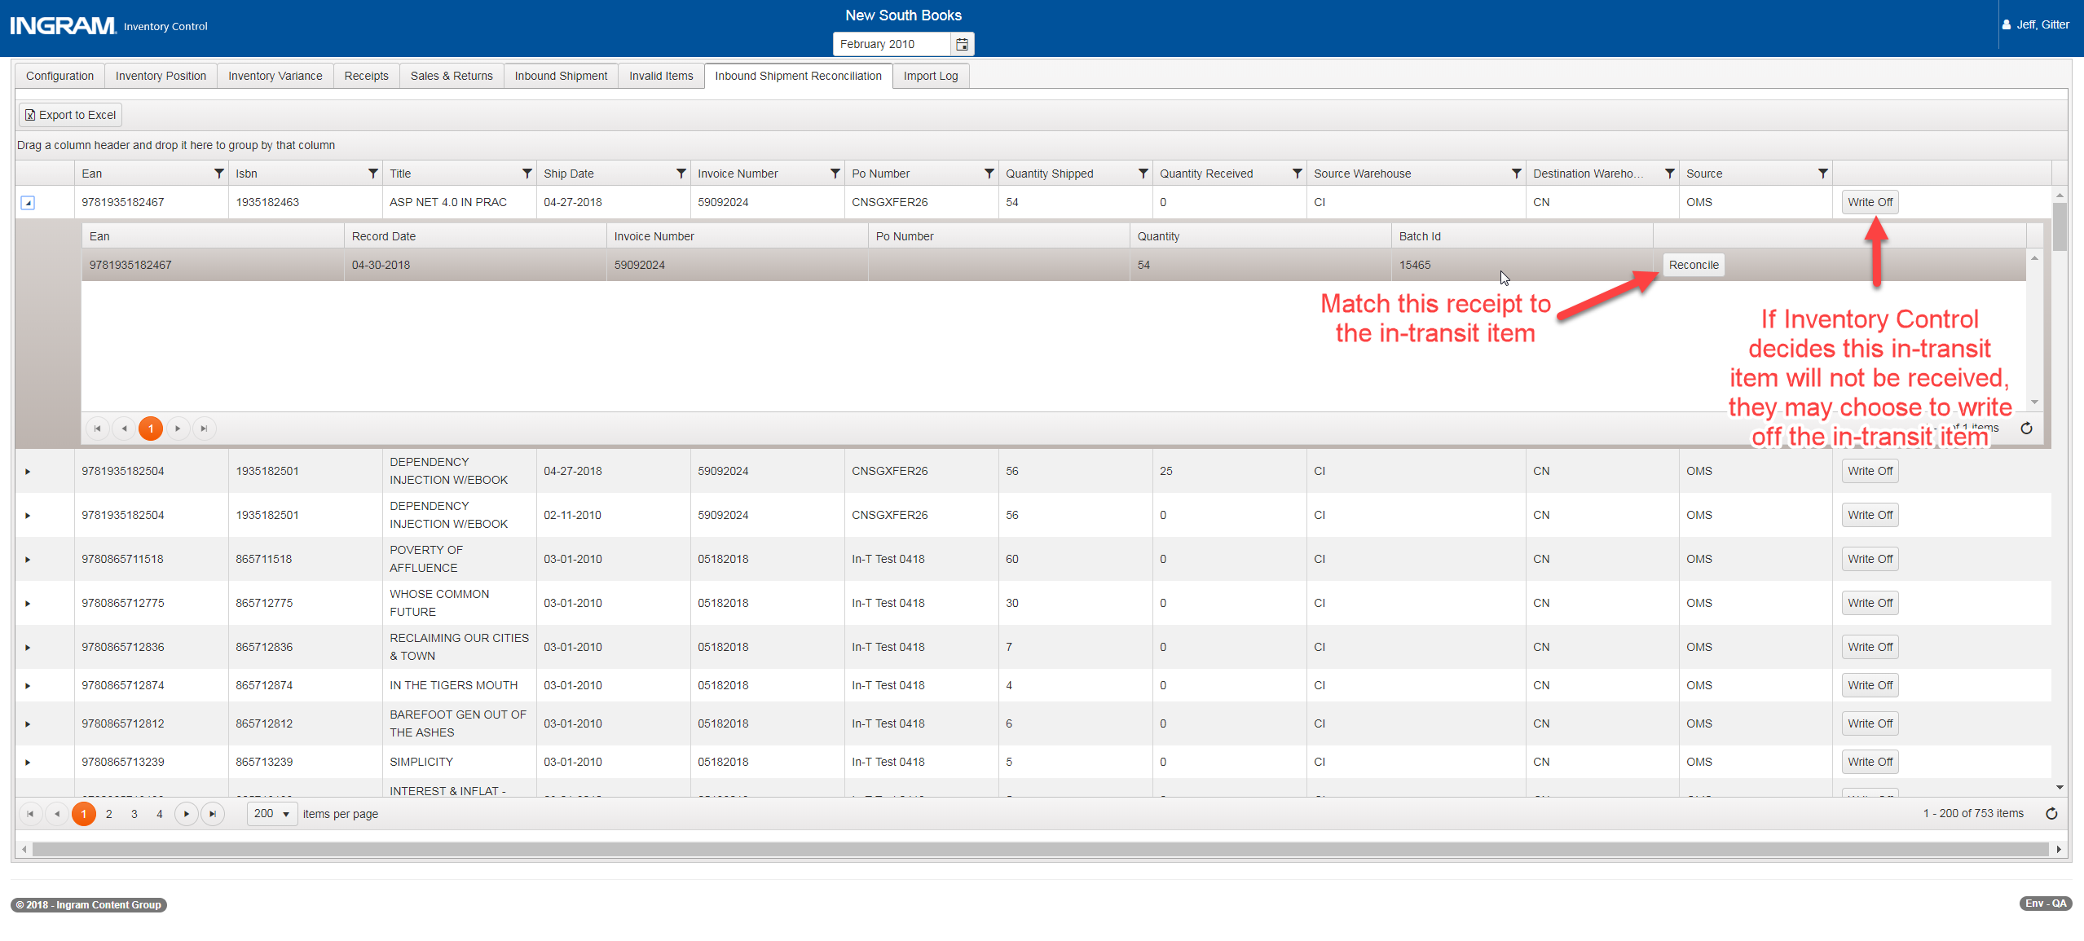

Daily Report Job: In-transit Ledger
New In-transit data will be reported to ODS daily as part of the 7pm Daily Report job. Also, in-transit quantities that have been matched to a receipt or written off will be decremented in iQ when the Daily Report job runs at 7pm. When a receipt is matched to an in-transit item, the existing in-transit stock position will be decremented and the “awaiting stock” position will be incremented for the given EAN. When an in-transit item is written off, the in-transit item will be decremented only and ODS will create an auto-adjustment transaction. Receipt transactions will not be reported automatically but must be approved on the Receipts tab. When the inventory position data is released, the receipt position from the inventory position file will be reported as a receipt transaction, and the “awaiting stock” position will be decremented to zero. (See section Daily Report Job: Inventory Position for more details.)
Note that any in-transit items reconciled to a receipt will not be displayed as “awaiting stock” if the inventory position data is approved on the same day! The inventory position’s receipt transaction accounts for any reconciled in-transit items reported on the same day, then the “awaiting stock” value begins again the following day.

Automatic Receipt Reconciliation
Consignment Warehouse will attempt to automatically match receipts to existing in-transit ledger items when receipts are imported according to the rules listed below:
- Receipt EAN matches in-transit ledger EAN
- Receipt record date is after in-transit ledger date
- Receipt PO Number, if available, matches the in-transit ledger PO Number, if available
- If PO Number is not available, receipt invoice number, if available, matches the in-transit invoice number, if available
- The receipt quantity is less than or equal to the in-transit ledger quantity

Receipt Release and Reporting
Receipts may be released for reporting to publishers by clicking the “Release” button. Receipts may be released at any time throughout the month, but will be published once with the inventory position data. Only inventory control users may release receipts, and approved receipts may still be matched to in-transit ledger items. Only AR warehouses will send receipt data, and the data will be added to the F_Receipts table in ODS.
Receipts may be imported for Non-AR warehouses and added to the NonAR_F_Receipts table in ODS. These are imported using the inventory position file, and may be matched to in-transit items, if any exist for the non-AR warehouses. Reconciling in-transit items is not required for non-AR warehouses.
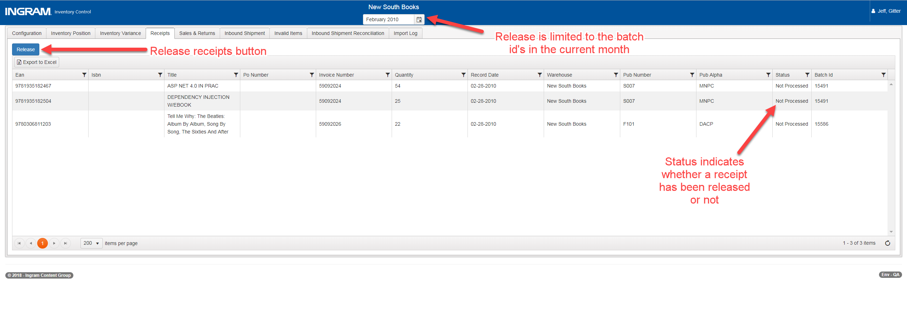

Sales/Returns Data Release and Reporting
Sales and returns data may be released for reporting to publishers by clicking the “Release” button. Sales and returns may be released multiple times throughout the month, but no more than once per day. Only finance team users may release sales and returns, and sales and returns should be published along with monthly inventory position data after review by the finance team. Unlike inventory, sales and returns data may not be manipulated within the consignment warehouse application—it may only be approved or deleted (see section “Delete Imported Files” for deleting data).
All sales and returns data is handled at a transaction level, and no validation exists that prevents users from importing identical sales or returns transactions. Therefore, it is critically important that the finance team carefully reviews the data once imported to ensure it is accurate. Once approved, the sales data will be sent to the ODS table F_Sales for AR warehouses, or the NonAR_F_Sales table for NonAR warehouses. Similarly, the returns data will be sent to the F_Returns table for AR warehouses, or the NonAR_F_Returns table for NonAR warehouses.
Sales and Returns data is released by batch id. Therefore, finance team members should ensure all data imported from a single file has record dates limited to a single month.
When the Sales and Returns data has been approved, the “Release” button will be disabled, and if additional sales and returns data is imported, the release button will be re-enabled.
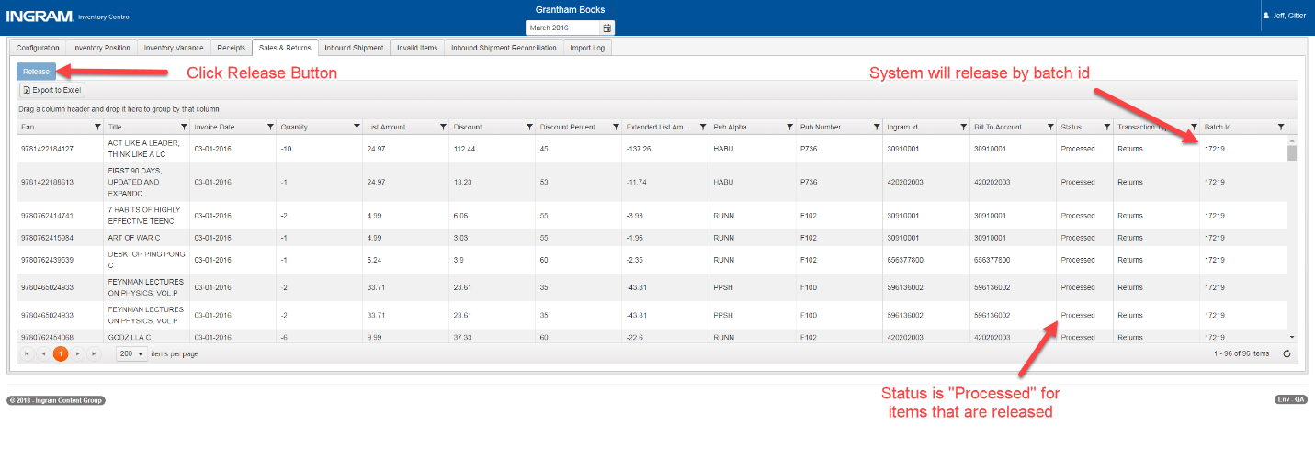

Client Statements Integration
Consignment Warehouse reports sales data to Client Statements via the data published to ODS. Published sales will be included in the next statement based on the date the data is released, and the transactions will use the published date as their transaction date. For example, if Sales/Returns data is imported on April 15th, released on April 25th, and published on April 30th, it will be included on the Client Statement generated in May, but if it is published on May 1st, it will be included on the Client Statement generated in June.

Client Statements will pull the released data once per day. Therefore, users should not approve sales data for the same warehouse more frequently than once daily. NonAR warehouses do not report their sales data to Client Statements.
Data for the same warehouse for two months may not be approved on the same day, but data for two different warehouses and the same month may approved on the same day.

Customer Mapping
For any warehouse that supplies customer account number, Consignment Warehouse will attempt to record the customer account number, customer name, address, and country. Customers may be viewed but not edited through the “Customers” tab. As of version 1.3 in October 2018, GBS supplies customer number, name, address and country, and Wiley UK and APD supply customer number and name. All other warehouses supply a generic customer account that will be manually added to ODS during deployment. Only new customers will be added when sales/returns data is released, and existing customers will be linked to the related sales transactions.

Publishing Consignment Warehouse Data
Once inventory position, sales, and receipts data has been released for a given warehouse and month, that month’s data may be published to client statements, Qlik and iQ via the ODS database. This feature has been added to conform the data to restraints in ODS which require inventory transactions to display a corresponding date to sales and receipt transactions. Please note the sales and receipt transactions from the inventory position file are aggregate values and won’t match exactly in Qlik and iQ.
Any inventory or finance team manager may publish any warehouse’s data for a given month, given all file types have been released. The publish button will not be enabled until all three data types have been released by their respective teams. Ultimately, the user who releases the data is responsible for validating that data, not the user who publishes; however, inventory and finance teams should cooperate and communicate regarding the publishing of data so that deadlines for all teams are met. Once data has been released, it may not be un-released without intervention from the development team.
Users may opt to publish one data type without the others should a business reason arise for it. This is not recommended for normal months because the inventory transactions will not share the same date as the sales and receipt transactions, and there is no way to correct those transactions without intervention from the development team. However, finance team members may override the normal publish functionality for the sales data, and inventory team members may override for inventory and receipt data. In-transit data and receipt reconciliation does not need to be published, it will be reported to ODS as the transactions occur.

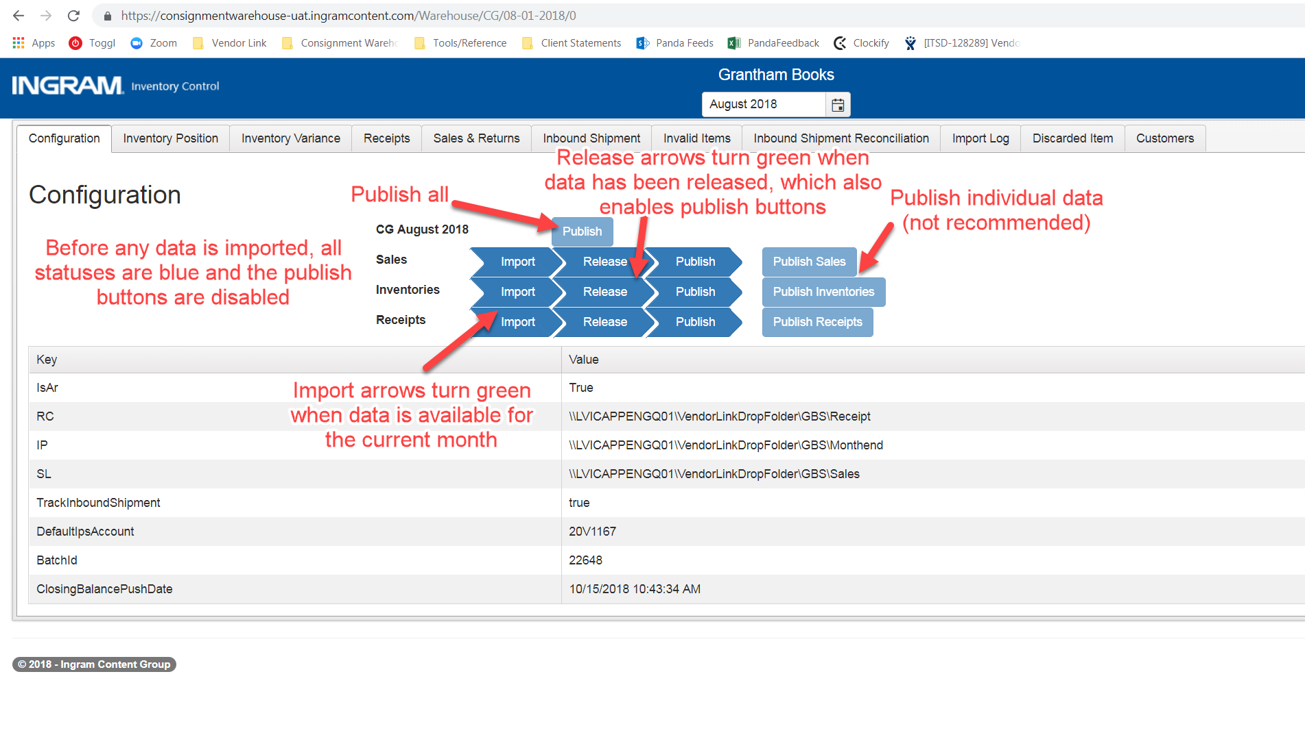
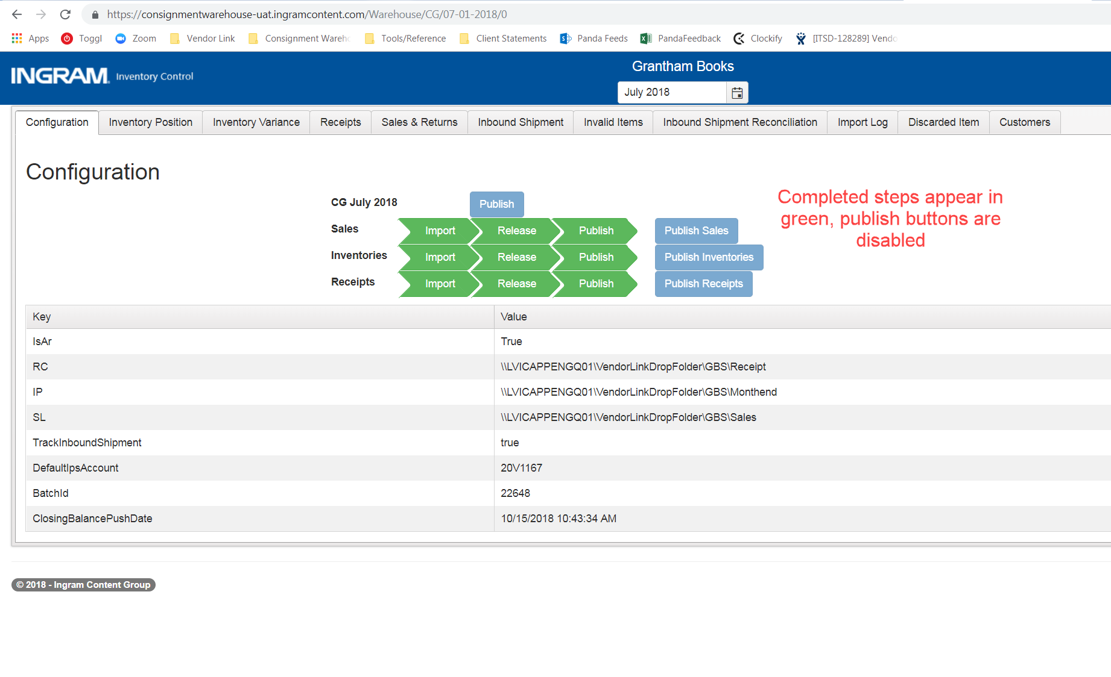

Invalid EANs
If an EAN does not exist in the ODS database, Consignment Warehouse will add it to an error queue so that it may be reported after the EAN is added. Users may view the invalid items for a given warehouse on the “Invalid Items” tab, selecting the invalid records by the date they were imported. Columns have been added for sales records so that finance team members may quickly and easily check net sales and units for invalid items. Inventory and receipts data values will not be visible on the Invalid tab. See the illustration below for additional detail:
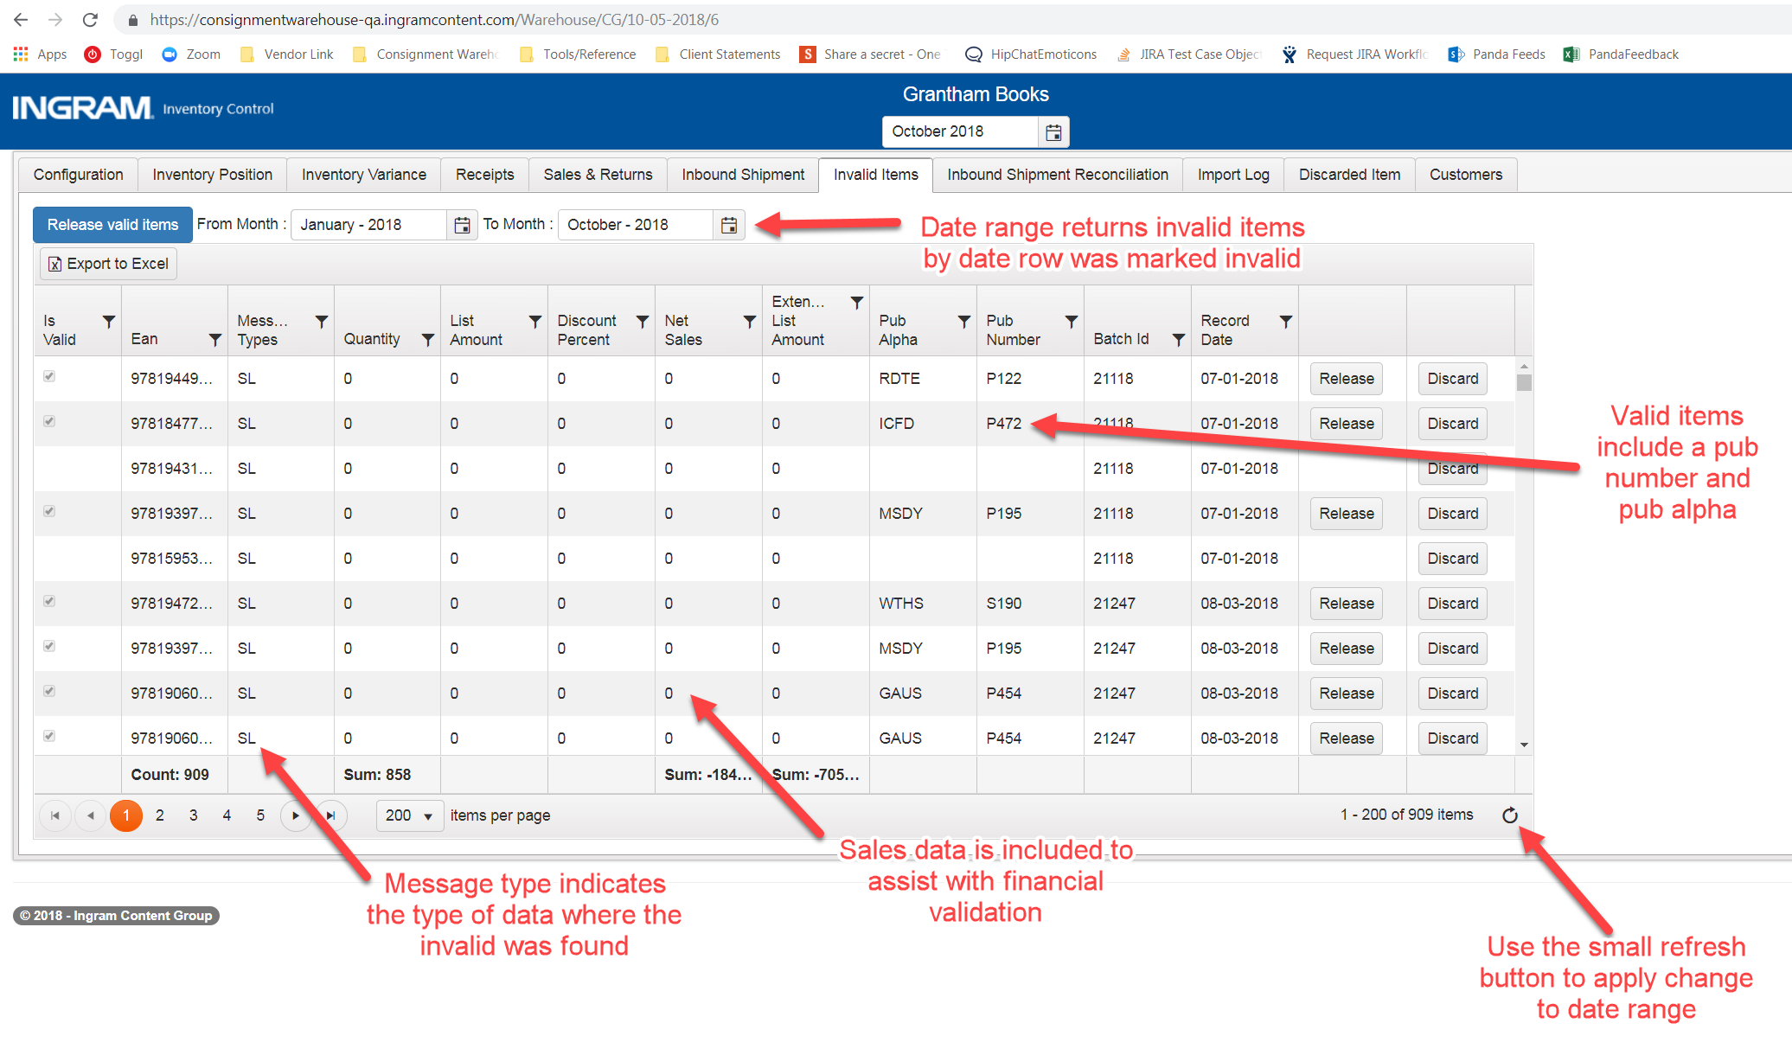
When the grid loads, Consignment Warehouse will check the ODS database for each listed EAN. If it finds the EAN has been added, it will set the “IsValid” column to “True”. Any user may then click the “Release Valid Items” button to add all the valid items back to the appropriate tabs within Consignment Warehouse. Releasing invalid items does not release them to iQ. Conversely, users may click the “Release” button inside the grid to release one record at a time. Users may also discard an invalid item when they identify the EAN will never be made valid by clicking the “Discard” button.
When releasing using the “Release Valid Items” button, items are released by EAN, not by file type. Therefore, any user may release invalid items and should be aware of how releasing those EANs will affect both inventory control and finance. Users may release a single EAN by clicking the release button inside the Invalid Items table or may release all valid EANs by clicking the “Release valid items” button above the table. The “Release valid items” button will disregard any filters applied to the grid when releasing EANs. Filtering the grid will not limit the EANs released this way.
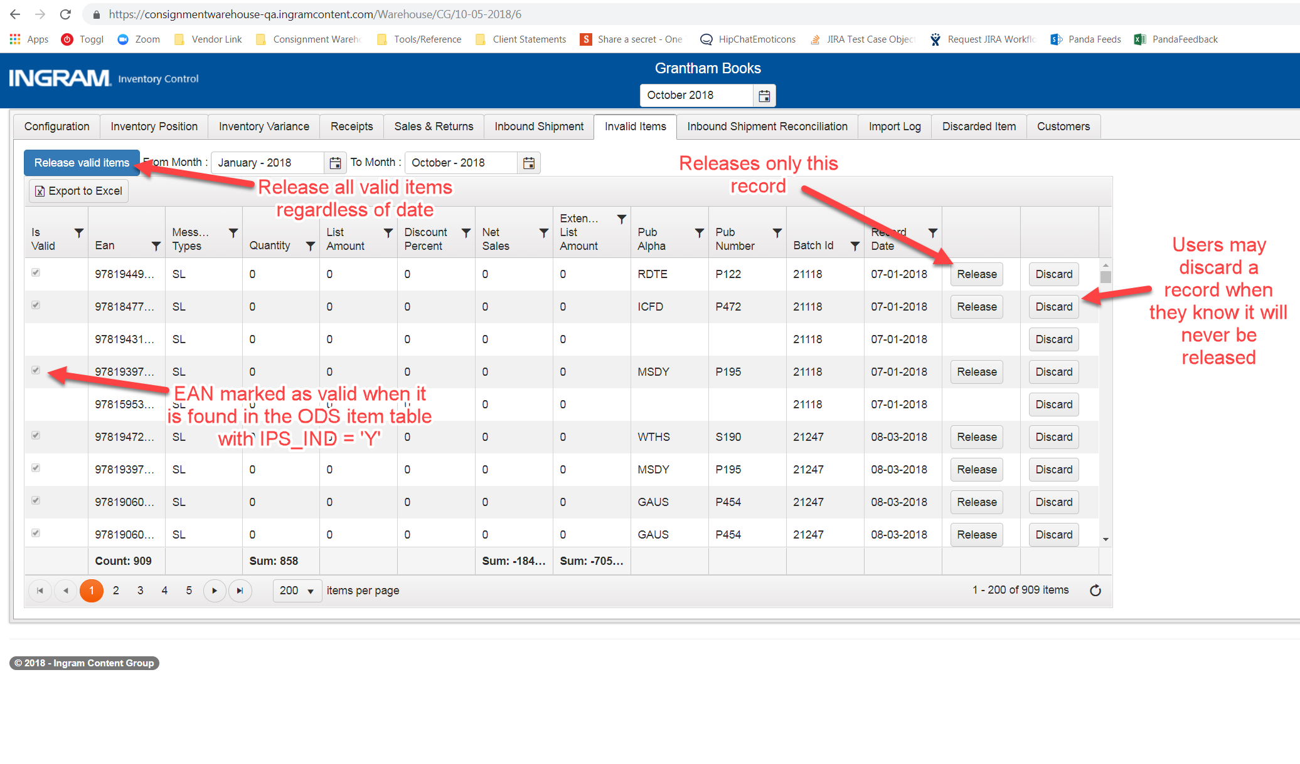

Inventory Position Invalid Release Rules
Inventory position data will be released to the month to which it was reported. If the inventory position has already been approved for that month, an inventory control user will need to approve the data again for the invalid EAN to be included in that month’s report.
Tip: If an inventory control manager wishes to only release inventory data, select a month where sales and receipt data has already been approved.

Receipt Invalid Release Rules
Receipts will be released to the current selected month but may not be released to any month where receipts have already been released.

Sales/Returns Invalid Release Rules
Sales/Returns data will be released to the current selected month but may not be released to any month where sales/returns have already been released. Therefore, multiple months of sales and returns data could be reported to Client Statements in a single month.

Discarded EANs
If an EAN in the inventory position file has no activity and no quantity on hand, or the EAN does not belong to an IPS publisher (ODS Item table IPS_IND = ‘N’) then that inventory position row will be discarded. Discarded EANs will appear on the “Discarded Item” tab in the month the file was uploaded to so that inventory control users may verify all rows from an inventory position file are accounted for. Discarded items may not be released back to the inventory, receipts, or sales tabs. Users may also click the “Discard” button on the Invalid tab to optionally remove an EAN from the list of Invalid items. Receipt and Sales data may only be discarded through the Invalid Items tab.
Consignment Warehouse will discard an EAN from the inventory position file automatically according the rules below:
Rule | Displayed Reason
The EAN has no activity and no quantity on hand | No Activity
EAN does not belong to an IPS publisher (IPS_IND = ‘N’ in the ODS Item table) | Not an Ingram Publisher
User clicks the “Discard” button on the Invalid Items tab | Discarded from Invalid EAN Screen

To discard an EAN from the Invalid Tab, click the “Discard” button

