- Logical Reserve
  - Logical Reserve for a specific customer
    - Rep will enter XR order type on customer's bill-to account number in OMS mainframe OE01
    - Person making the request to reserve inventory should be entered in the Contact field
    - Reference information should be added in the PRIM PO field
    - Enter XR in the ORDER TYPE field
    - Enter another XR order If the amount of inventory on reserve for the specific customer needs to be increased
    - IB14 will show the amount reserved in the RESERVE QTY field
    - Ingram IQ will show reserved inventory
    - Once XR inventory is depleted by orders for the customer's bill-to, the title will no longer show as reserved, and there will be no record of the reserve request (other than the title showing invoiced to the customer)
    - XR orders can be entered prior to receipt of a title to reserve the title, and will show on backorder until stock received.

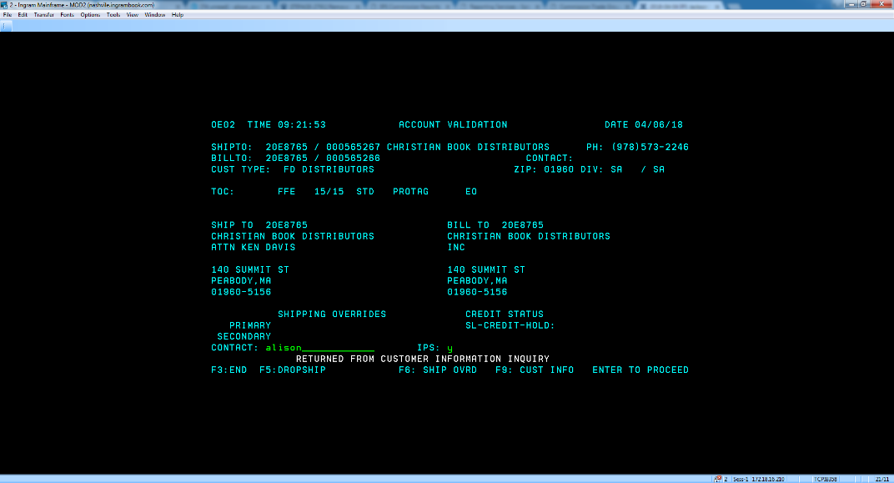

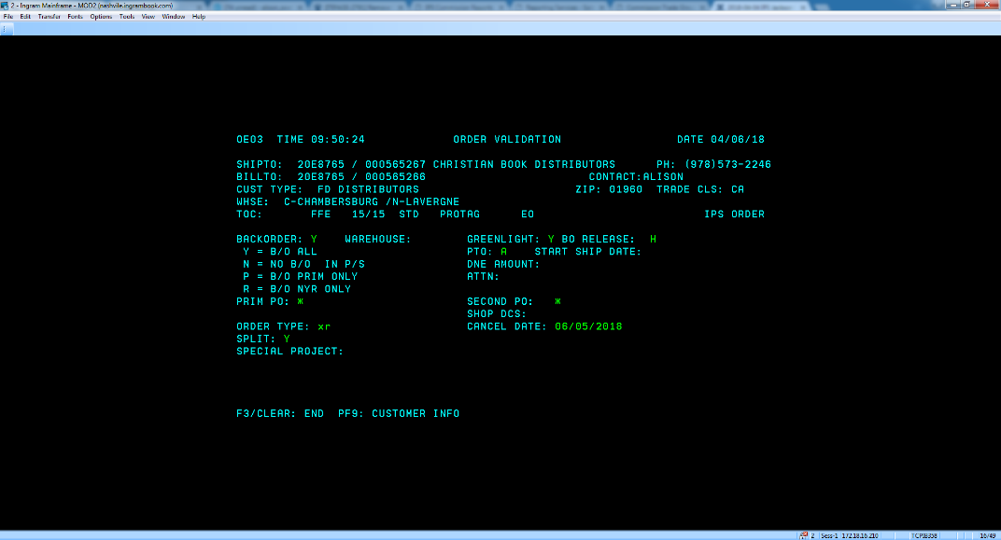

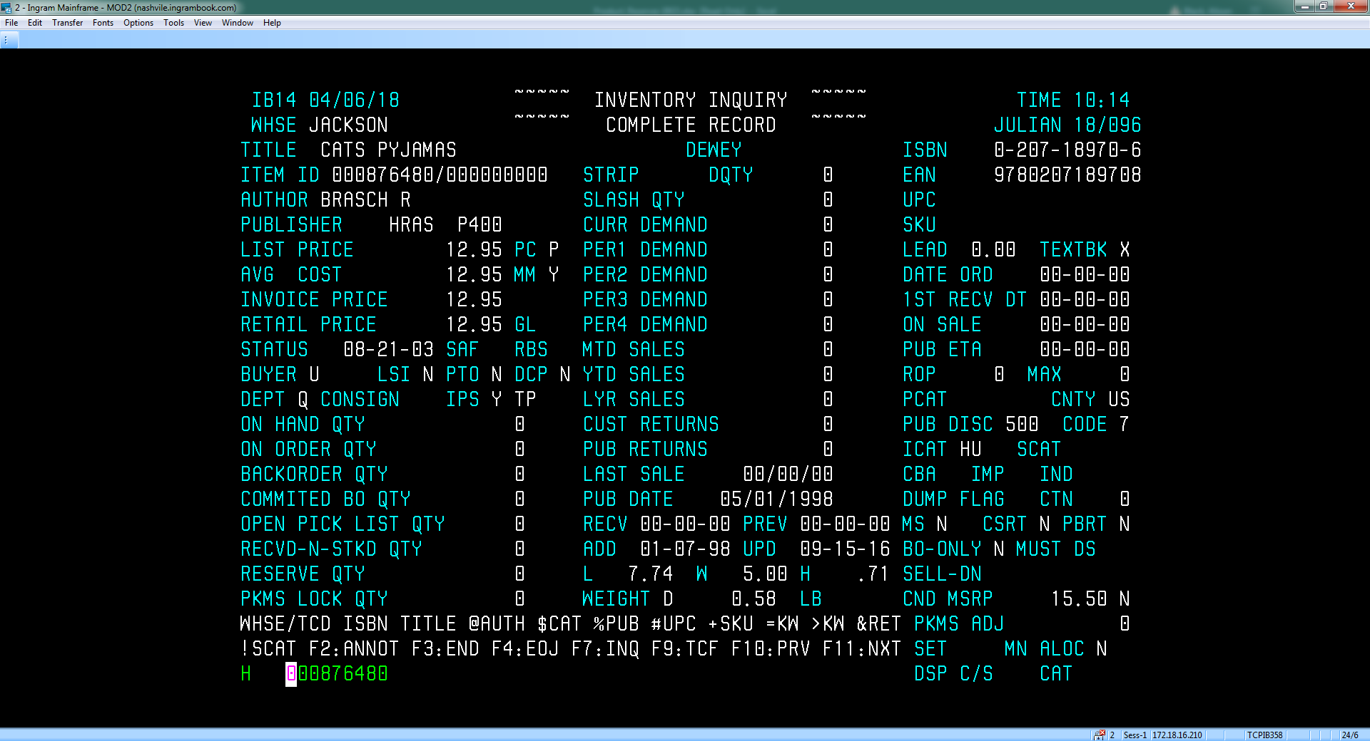

- Canceling XR Logical Reserve IT15
  - Type IT15 in a blank screen
  - Populate DC code (HH, CI, NV, DD, EE), Title Code/EAN, and Press Enter
  - Enter sequence number in the CHANGE SEQ field and Press Enter
  - Change Expire Date to today's date and press enter
  - Verify Expire Date Updated
  - Reserve will expire overnight
  - If title needs to be released from reserve same day, send email to : ProdCntl@ingrambook.com (IBC MIS PRODUCTION CONTROL) requesting to run the logical reserve expiration job: IBIT760N for LaVergne, IBIT760C for Chambersburg, ITIB760D for Fort Wayne, IBIT760E for Roseburg, and/or ITIB760H for Jackson today.
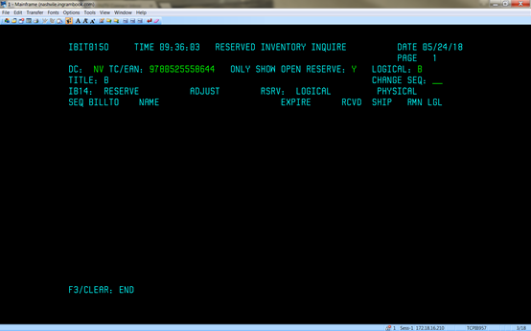
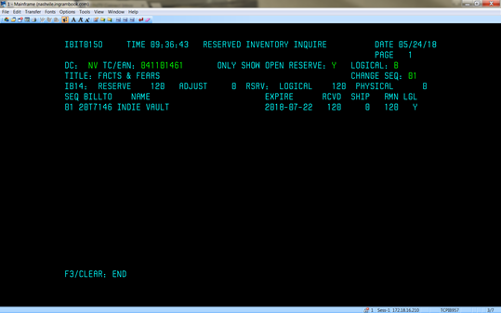
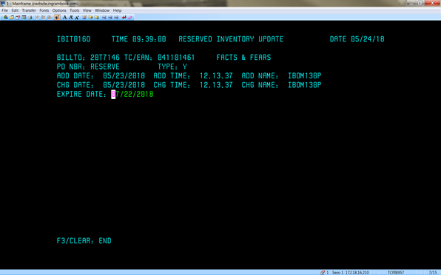
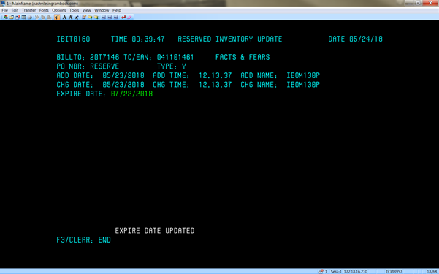
- Logical Reserve
  - Logical reserve NO specific customer

      - Rep will enter XR order type on the IPS Reserve Inventory account (20V3638) in OMS mainframe OE01
      - Person making the request to reserve inventory should be entered in the Contact field
      - Reference information should be added in the PRIM PO field
      - Enter XR in the ORDER TYPE field
      - Enter another XR order if the amount of inventory on reserve for the specific customer needs to be increased
      - To allocate inventory reserved to a specific order, rep uses OM60 option U to draw inventory from the IPS Reserve Inventory pool (IPS RESERVED to Y)
      - Priority can be viewed in OM02 on a title level in the P field
      - Ingram IQ will show reserved inventory
      - XR orders can be entered prior to receipt of a title to reserve the title, and will show on backorder until stock received
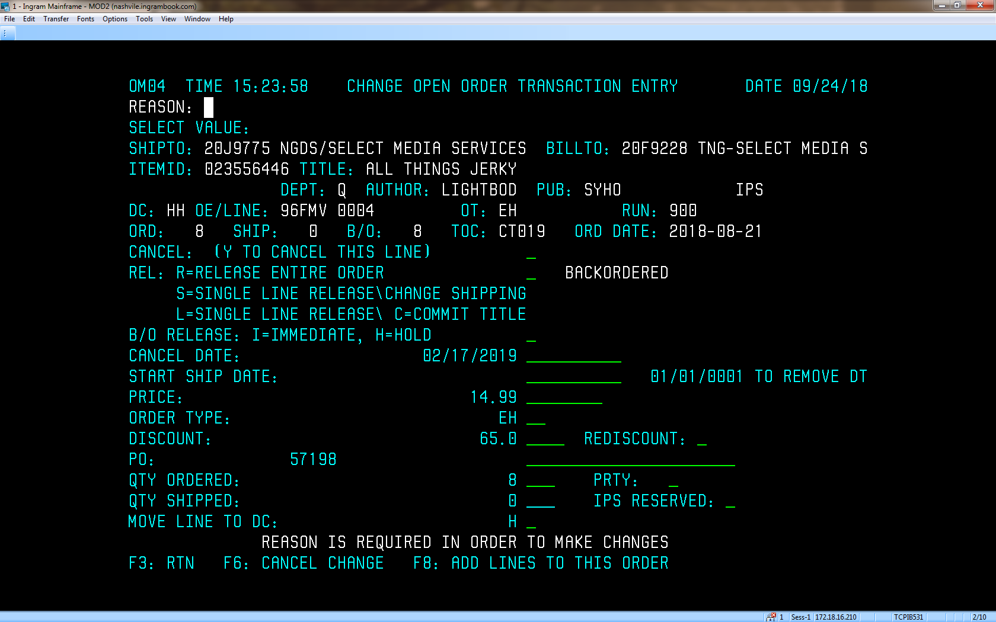

- Manual Allocation
  - Manual allocation is used to reserve ALL inventory for a title in OMS
  - When a title is on manual allocation, the inventory moves from on hand to on order in IT30
  - Publisher direct fulfillment (DF) accounts bypass manual allocation
  - Publishers can manage all manual allocations via subscription Allocation reporting in IQ
  - A title can be put on manual allocation at any time
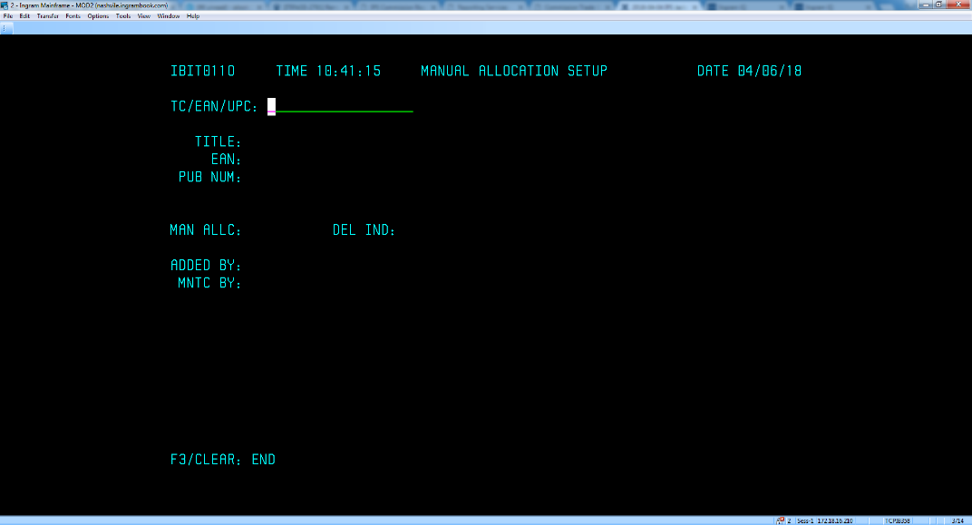
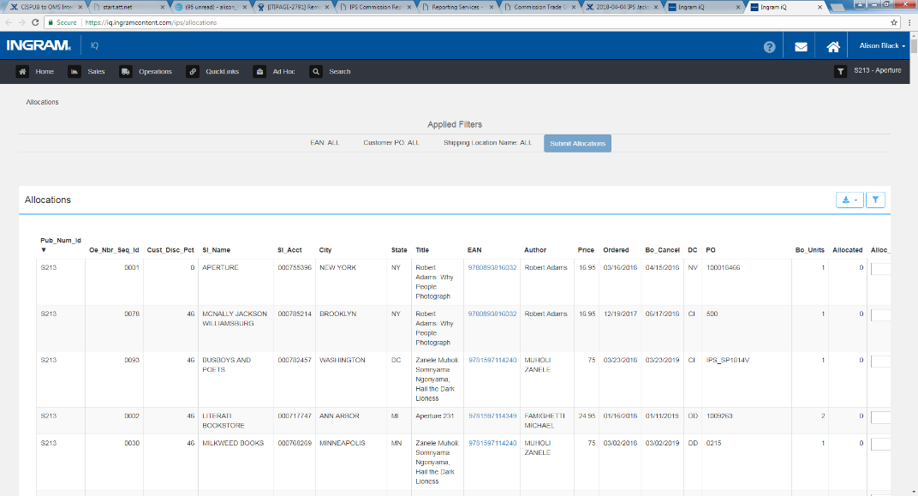
- Locked Inventory
  - Locked inventory is not reserved inventory in OMS
  - Stock pending putaway will show in the RECVD-N-STKD QTY field in IB14
  - Locked stock will show in the PKMS LOCK QTY
  - Locked stock will show in IQ as locked
  - Items archived for clients as LT 63 items will remain locked after OMS conversion
    - Orders for these items are few and far between
    - Items are accessed manually via a work order
